# Mobile Security Lab 1

|  |
| --- |
| **emulator -avd <name of the avd> -scale 0.85 -no-boot-anim** |

Question: What do the arguments of the emulator command mean?

“- scale <0.1 to 3>” = scale the emulator window

<scale> is a number between 0.1 and 3 that represents the desired scaling factor.

You can also specify scale as a DPI value if you add the suffix "dpi" to the scale value.

A value of "auto" tells the emulator to select the best window size.

“-no-boot-anim” = Disable the boot animation during emulator startup.

Question: How long did the emulator take to boot? Why? Will HAXM help? What is the benefit of HAXM?

The emulator boot around 1 minute with HAXM installed. Hardware Accelerated Execution Manager (HAXM) is a hardware-assisted visualization engine, uses Intel virtualization technology to speed up Android App Emulation on a host machine.

Question: Android has an emulator and iOS has a simulator. What’s the difference between an emulator and a simulator?

Emulator allows the host system to emulate the virtual hardware and software to the actual devices in terms of hardware and software environments.

Whereas, simulator only provides the software environment and has access to all the host system resources.

Question: What does the ps command do?

Report process status

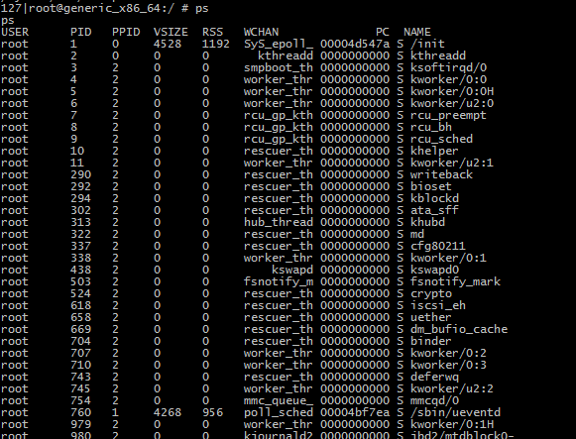

Question: What does the df command do?

report file system disk space usage

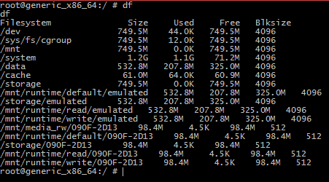

Question: What does the top command do?

Check CPU usage according to the running processes

-m is the number of processes to be shown each time

DDMS – Dalvik Debug Monitor Server (DDMS)

* Port forwarding services
* screen capture on the device
* thread and heap information on the device
* logcat
* process
* radio state information,
* incoming call and sms spoofing
* location data spoofing
* etc

Question: How do you spoof location? How do you spoof SMS?

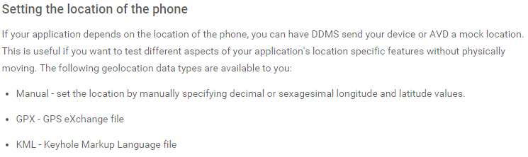

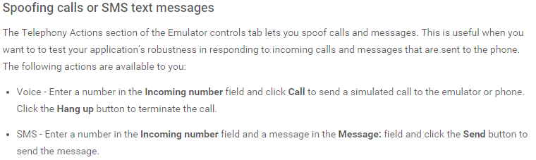

Question: Can you do this via command line? What commands should you issue?

<http://lists.hackerspaces.org/pipermail/discuss/2012-November/006905.html>

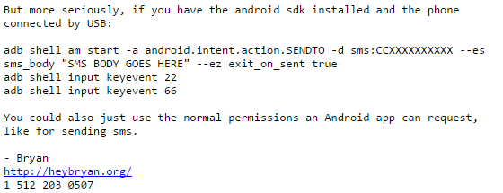

<http://stackoverflow.com/questions/2279647/how-to-emulate-gps-location-in-the-android-emulator>

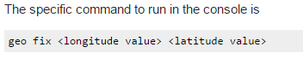

Question: How do you use busybox to find all apks on the system?

“pm list packages”